**Question1:**

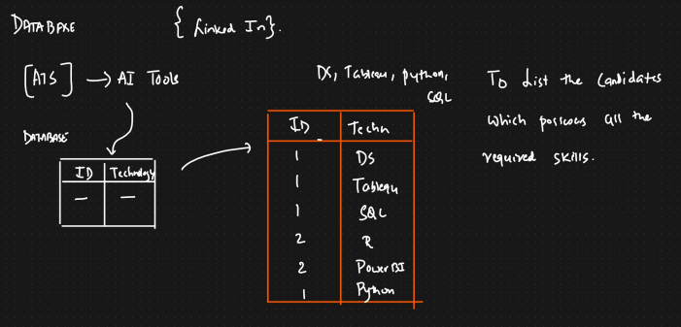

**Answer:**

**Table Creation scripts:**

create table skillset_tb

(

id int,

technology varchar(30)

);

**Data Insert Scripts:**

insert into skillset_tb (id,technology) values

(1,'Python'), (1,'SQL'),

(1,'Power BI'),

(2,'Python'),

(2,'Tableau'),

(2,'R'),

(3,'Python'),

(3,'SQL');

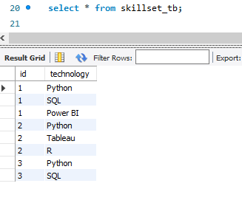

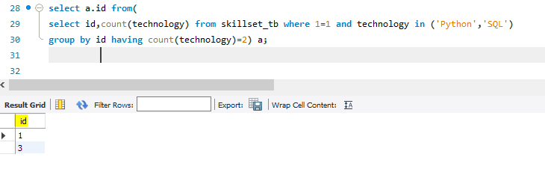

**Question 2:**

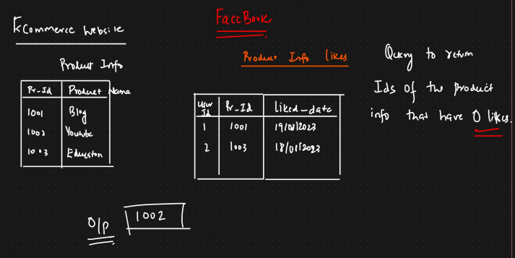

**Answer:**

**Table Creation scripts:**

create table product_info

(

product_id int,

product_name varchar(30),

primary key (product_id)

);

create table product_info_likes

(

user_id int,

product_id int,

liked_date date,

foreign key (product_id) references product_info(product_id)

);

**Data Insertion Scripts:**

insert into product_info (product_id,product_name) values

(100,'Blog'), (101,'Youtube'),

(102,'Linkedin'),

(103,'FB'),

(104,'Twitter');

insert into product_info_likes (user_id,product_id,liked_date) values

(201,100,'2023-08-01'),

(202,101,'2023-08-02'),

(203,102,'2023-08-03'),

(204,104,'2023-08-04');

**Product Info:**

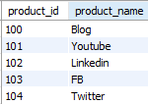

**Product Info Likes:**

